Case 4-Eur-Sweden-Stockholm-Viking-Battle Axe-1100 CE

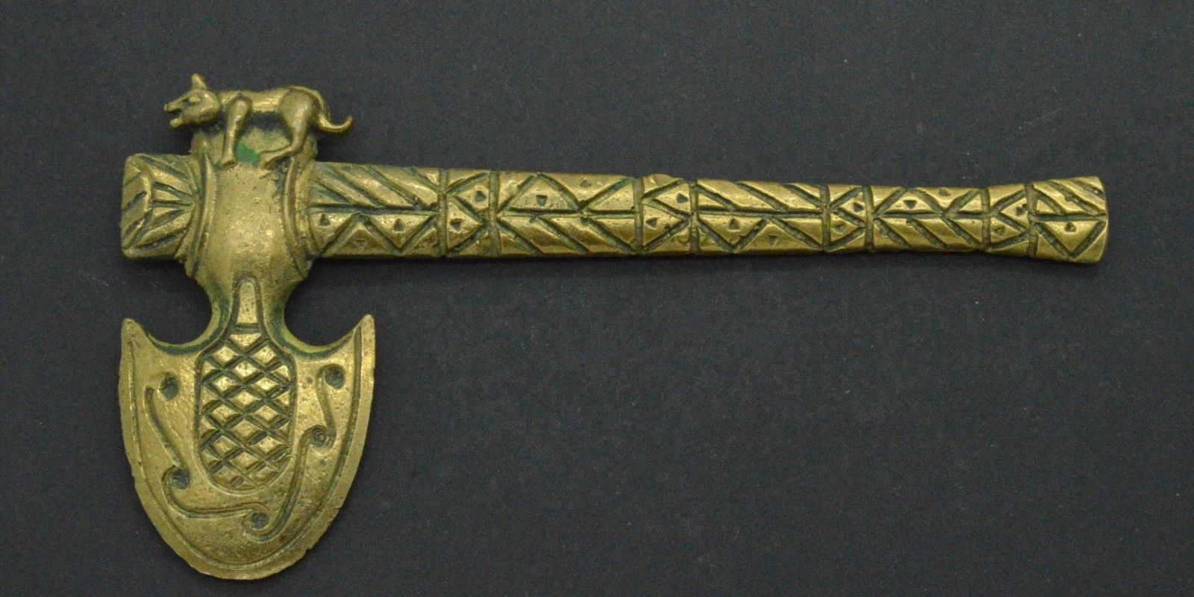 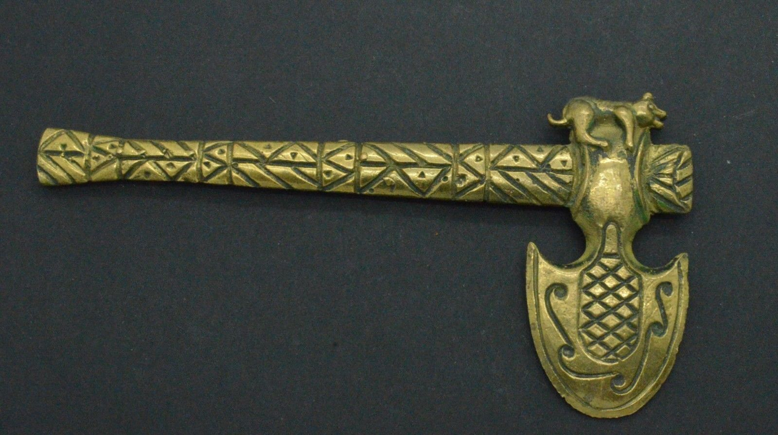

Figs. 1-2. Sweden-Stockholm-Viking-Battle Axe-1100 CE

**Case no.: 4**

**Accession Number:**

**Formal Label:** Sweden-Stockholm-Viking-Battle Axe-1100 CE

**Display Description** (extensively based on the articlewww.viking-source.com/Viking-Weapon-Facts/Viking-Battle-Axes.html:)

Medieval Norsemen relied on two basic types of axes as weapons, the hand axe and the long axe and these most often had served some useful tasks around the farm. When going off to war most Vikings of the early Middle Ages could not afford a weapon made specifically for battle, like a sword. They would often grab the same axe they used for woodcutting to serve as their weapon. This is especially true in the early Viking age. The hand axe was certainly not a very glamorous weapon. It was however, a very effective and deadly weapon. Skilled warriors could turn an opponent’s shield into splinters with their hand axe and easily kill them in close combat. Although effective, the everyday hand axe was not an ideal weapon. It was built for cutting logs and trees and therefore had to be heavy. A much lighter weapon could be used for hacking opponents. Lighter weapons were easier both to maneuver in battle and maintain repeated swings over a longer period of time without tiring the warrior as quickly as with a heavier axe.

As the Viking Age progressed from the early Danish incursions into England when the use of wood-cutting axes were the norm, Norse warriors developed more single-purpose weapons which were more effective, lighter and better suited for the battlefield.

**Viking Battle Axes**

While the length of the haft of both hand-axes and long-axes varied, they were usually one to five feet long (approximately 30 cm to 1.5 m) in length.

Blade sizes and thicknesses also varied. For example, the early so-called “bearded-axe” had an increased depth, making it heavier but more suitable for daily heavy duty woodcutting. The later Danish axe, on the other hand, had a wider, thinner blade.

Some axes had features such as horns at both the toe and heel of the bit. Others had a cap at the end of the haft to protect the top of the haft from being damaged.

Some axes, especially those of the Swedish Vikings, like the one being examined here, had engraved designs on their blades and their handles like the example we have here, which was designed as a pendant and was probably based on the design of a ceremonial axe. This may be a reflection of the fact that that the Swedish Vikings were naturally situated on the eastern Baltic Coast of Sweden near the rivers of Russia like the Vistula which they could traverse in their shallow-draft knarrs that could sail up the Russian rivers almost to Novgorod during the Medieval Warm Period (800-1250 CE) and then the knarrs could be portaged south to the Dnieper and the Dniester Rivers and could be sailed across the Black Sea and thence through the strait of Marmora into the Mediterranean Sea. In this traverse they encountered many Russian weapon designs that were then incorporated into the manufacture of their own weapons like this battle axe with a curved blade, a crisscrossed design on the handle with punctuates in the diamond-shapes thus created by the crisscrosses and, to indicate the fearsomeness of the warrior brandishing this weapon, a wolf was positioned at the haft of the blade which the opponent could see before being hit, all of which is unlike the usually plain and utilitarian Scandinavian designs.

**Viking Battle Axes: Hand-Axe**

Most Viking axes that have been unearthed have a single blade and look like wood-cutting axes. However, Vikings, over time, did improve the hand axe for fighting. They made lighter weapons with bigger wider blades. They added a hook to the lower end of the blade which could be used to hook the enemies shield. The hand-axe had some advantages over long-axes: they could be wielded with one hand allowing for the use of another weapon or for use of a shield for protection. A hand axe could be hidden behind a shield and then used to surprise an enemy thinking he is fighting an unarmed opponent.

**Viking Battle Axes: Long-Axes**

Long-axes were always made specifically for battle. They were usually three to five feet long (.9 meters to 1.5 meters). These weapons could be used to hack an opponent from a safer distance than the hand-axe. They were light and maneuverable with big wide blades. One disadvantage of the long-axe as opposed to the hand-axe was that two hands were required to swing it. This meant that the Viking warrior would not be able to hold a shield at the same time, thus leaving him vulnerable to the enemy.

* **LC Classification:** U813.V54

**Date or Time Horizon:** 1100 CE

**Geographical Area:** Stockholm, Sweden

**Map:**

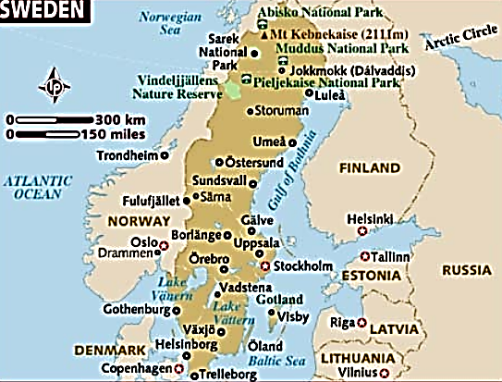

**Fig. 3. Map of Sweden showing location of Stockholm facing the Baltic Sea. After http://www.lonelyplanet.com/maps/europe/sweden/map_of_sweden.jpg**

**GPS coordinates:** N 59o 19’ 45”

**Cultural Affiliation:** E 18 o 4’ 6.89”

**Medium:** Bronze

**Dimensions:** L 16 cm

**Weight: see Display Description, above.**

**Condition: original**

**Provenance:** Stockholm

**Discussion:**

It should be noted that nowhere in the list of Viking battle-axe types is the famed Viking double-axe mentioned. Many popular images of Vikings storming villages in horned helmets are brandishing double-bladed axes. This is not historically correct. There is no archaeological evidence or historic documentation that the Viking warriors ever wore horned-helmets or used double-bladed axes.

**References:**

Oakeshott, R. Ewart, 1996. *The Archaeology of Weapons: Arms and Armour from Prehistory to the Age of Chivalry* (Dover Military History, Weapons, Armor) New York: Dover.

Siddorn, J. Kim. 2000. *Viking weapons & warfare*. London: Tempus.